Assignment 2

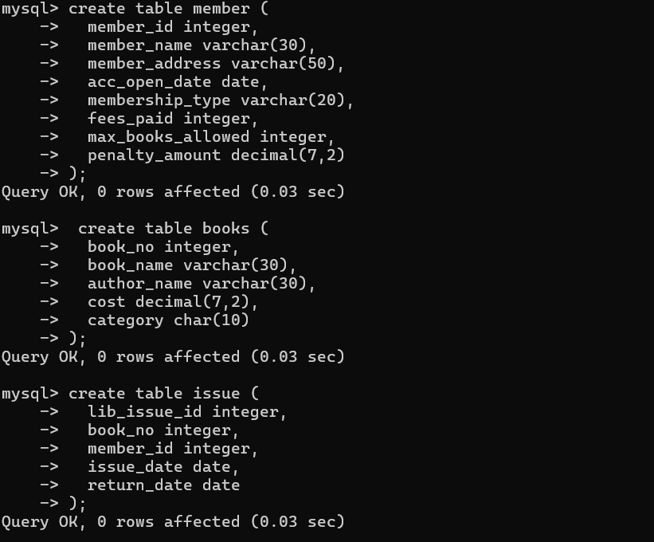1) Create the table Member, Books and Issue without any constraints as mentioned in the schema description above.

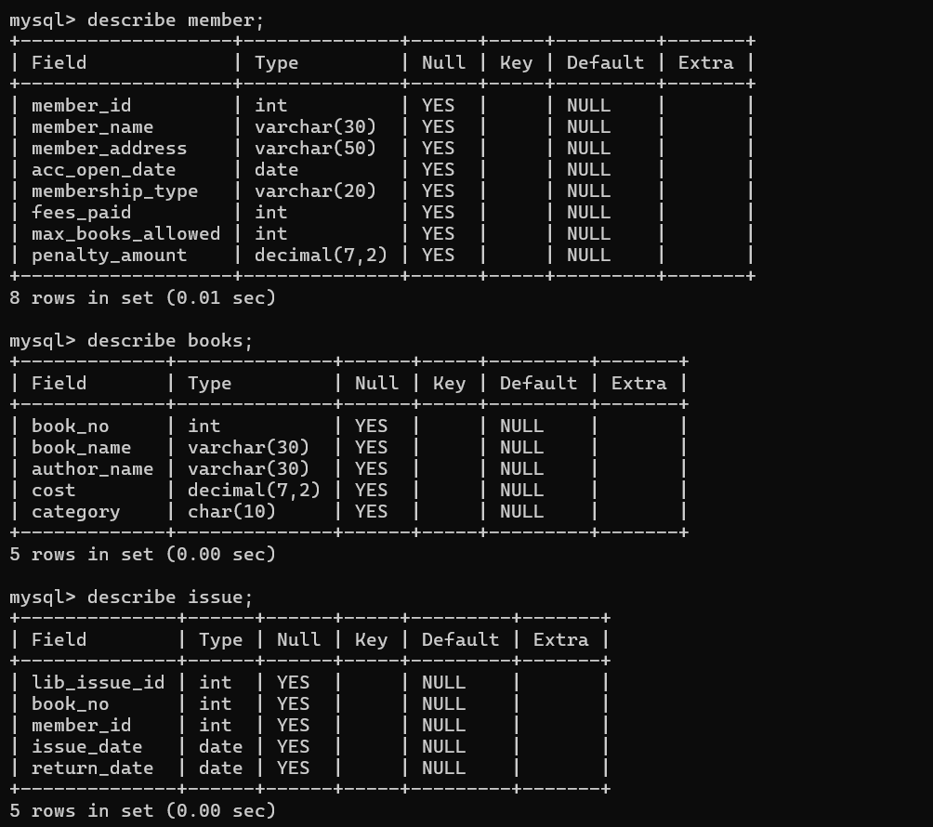2) View the structure of the table

3) Drop the Member table

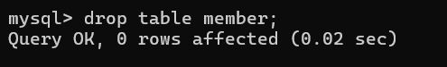

4) Create the table Member again as per the schema description with the

following constraints.

a. Member_Id – Primary Key

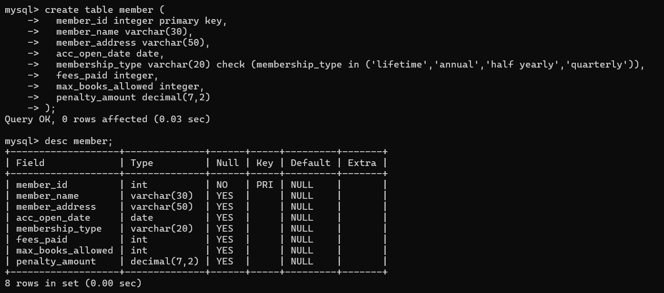b. Membership_type - ‘Lifetime’,’ Annual’, ‘Half Yearly’,’ Quarterly’

5) Modify the table Member increase the width of the member name to 30 characters.

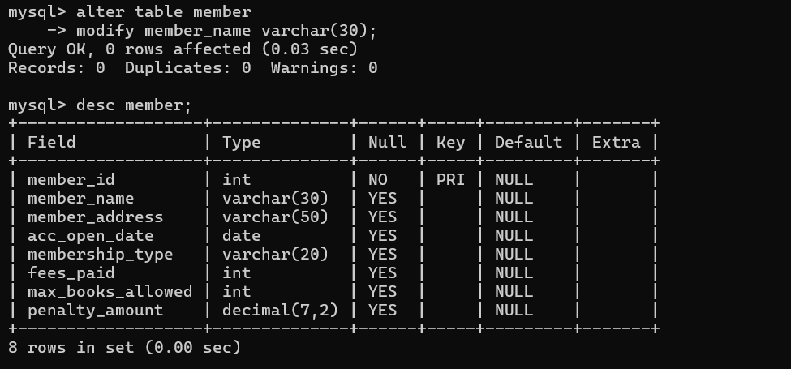

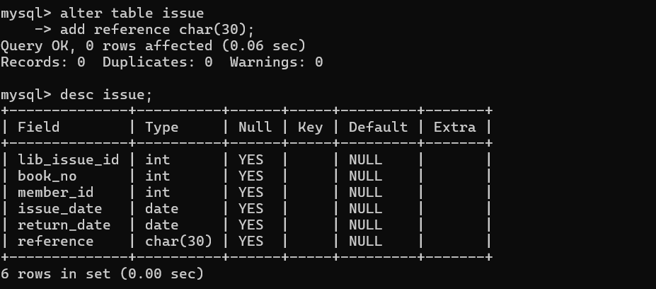6) Add a column named as Reference of Char(30) to Issue table.

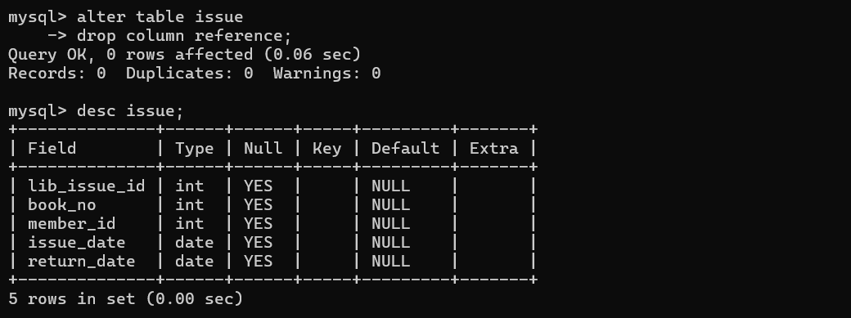7) Delete/Drop the column Reference from Issue.

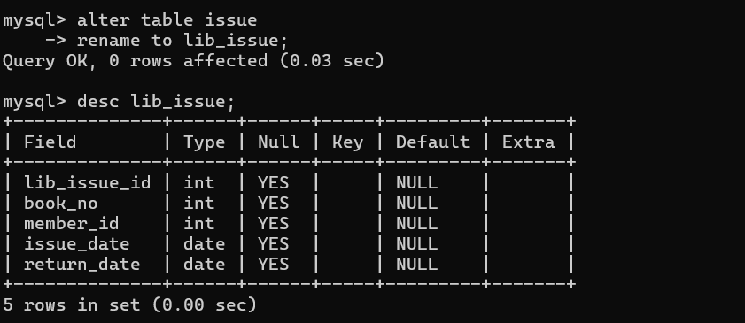8) Rename the table Issue to Lib_Issue.

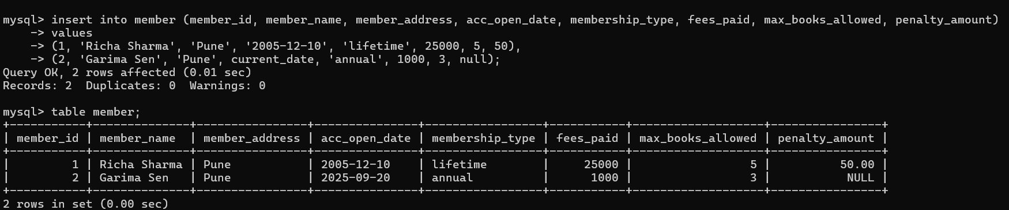9) Insert following data in table Member

10) Insert at least 5 records with suitable data.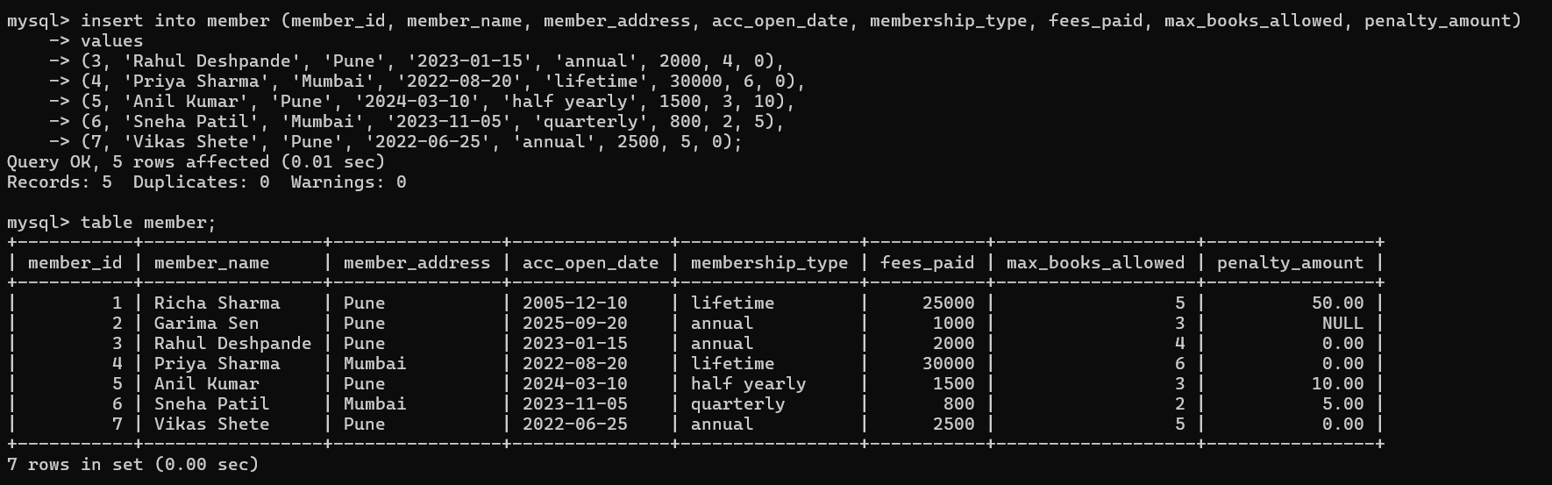

11) Modify the column Member_name. Decrease the width of the member name to 20 characters. (If it does not allow state the reason for that)

12) Try to insert a record with Max_Books_Allowed = 110, Observe the error that comes.

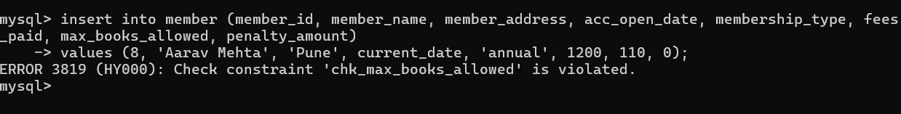

13) Generate another table named Member101 using a Create command

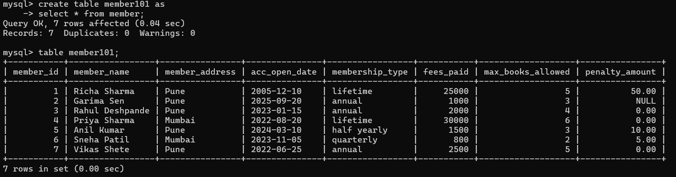along with a simple SQL query on member table.

14) Add the constraints on columns max_books_allowed and penalty_amt as follows

a. max_books_allowed < 100

b. penalty_amt maximum 1000

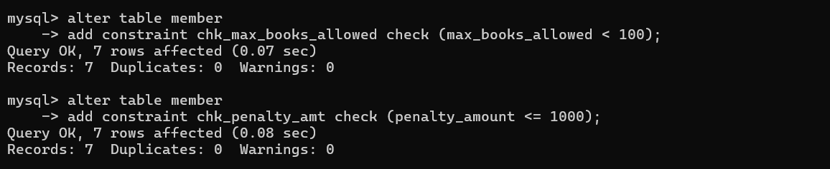Also give names to the constraints.

15) Drop the table books.

16) Create table Books again as per the schema description with the following constraints.

a. Book_No – Primary Key

b. Book_Name – Not Null

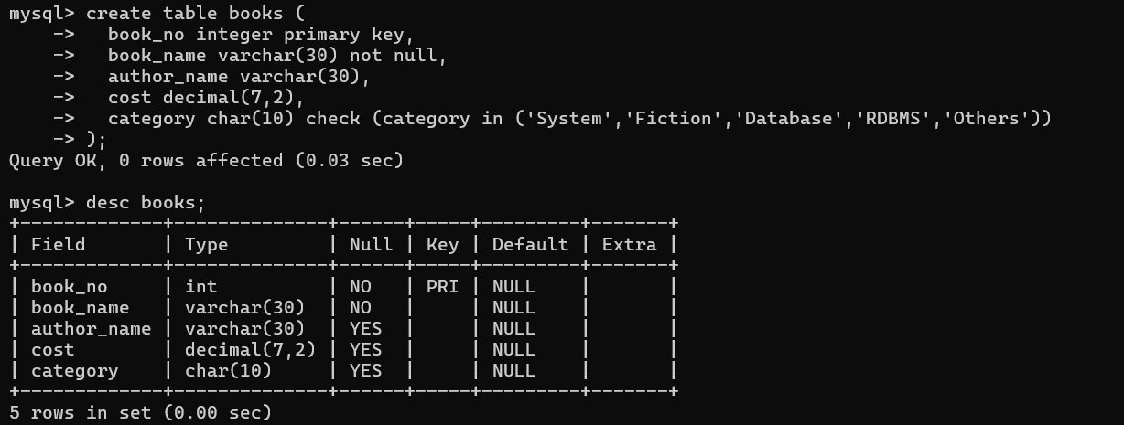c. Category – System, Fiction, Database, RDBMS, Others.

17) Insert data in Book table as follows:

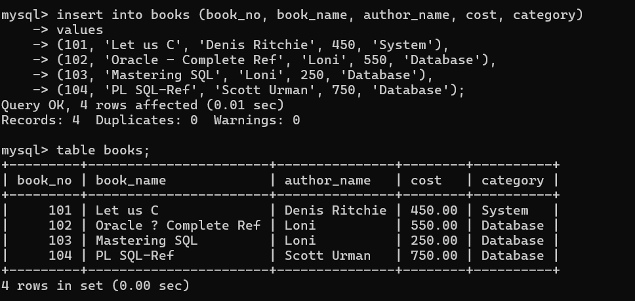

18) Insert more records in Book table.

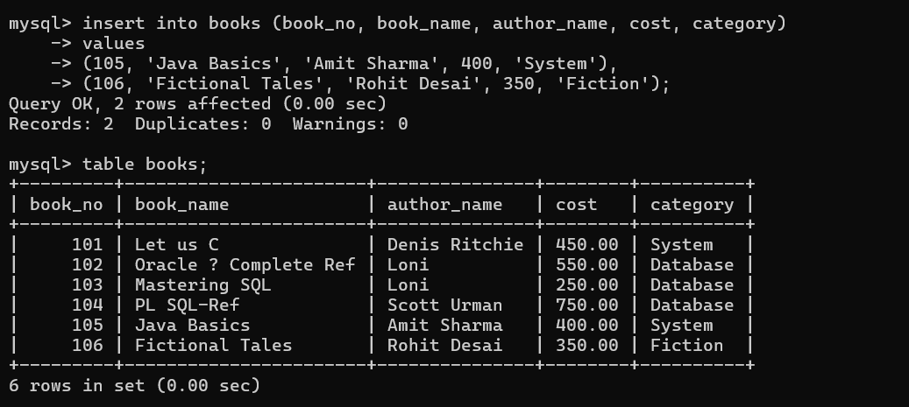

19) View the data in the tables using simple SQL query.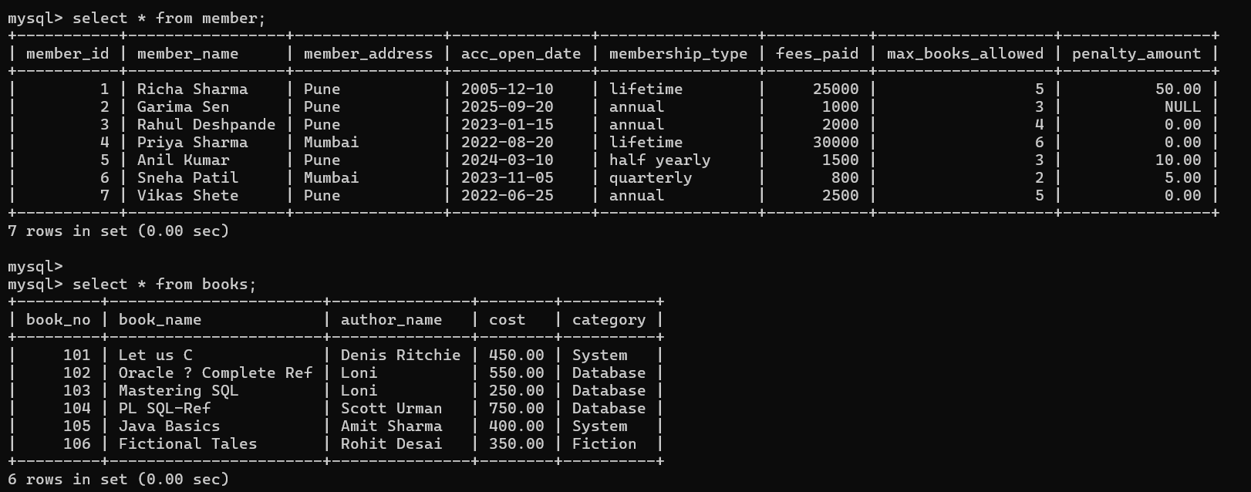

20) Insert into Book following data.

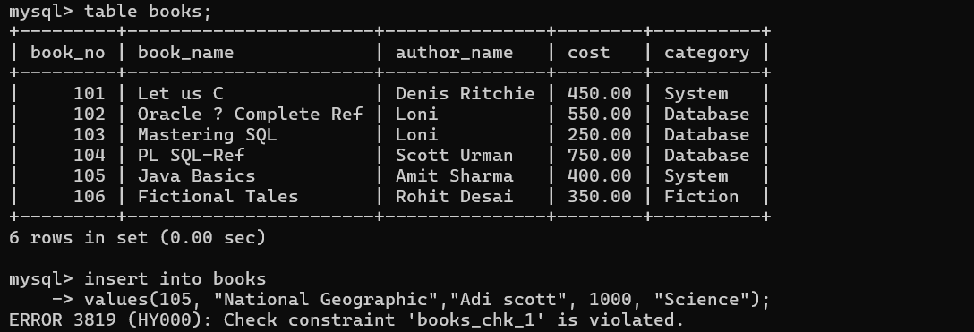105, National Geographic, Adis Scott, 1000, Science

21) Rename the table Lib_Issue to Issue.

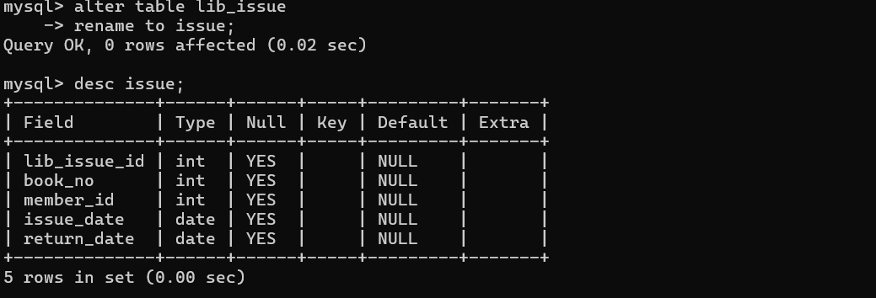

22) Drop table Issue.

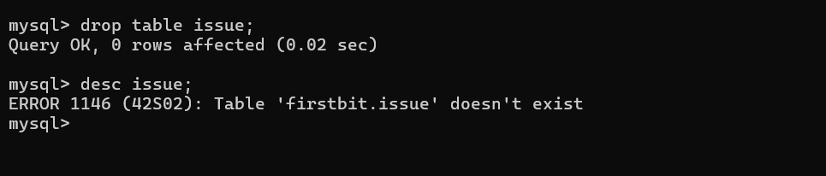

23) As per the given structure Create table Issue again with following

constraints.

Lib_Issue_Id-Primary key

Book_No- foreign key

Member_id - foreign key

Issue_date

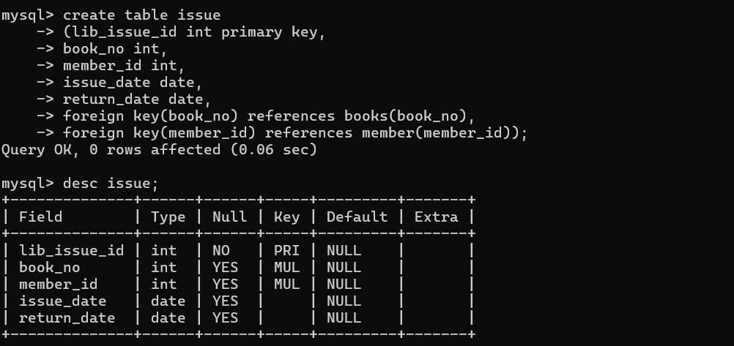Return_date

24) Insert following data into Issue table.

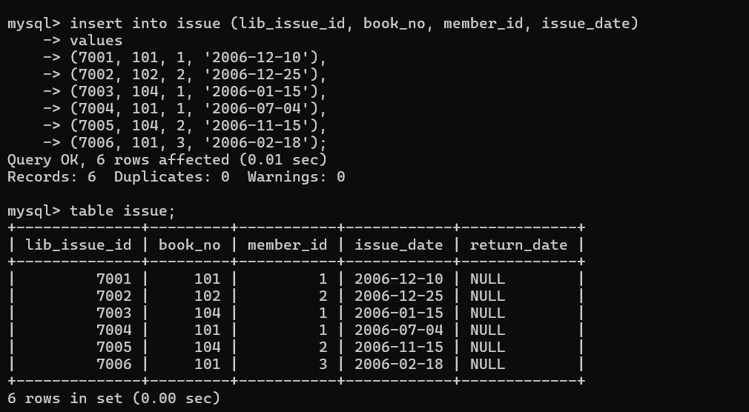

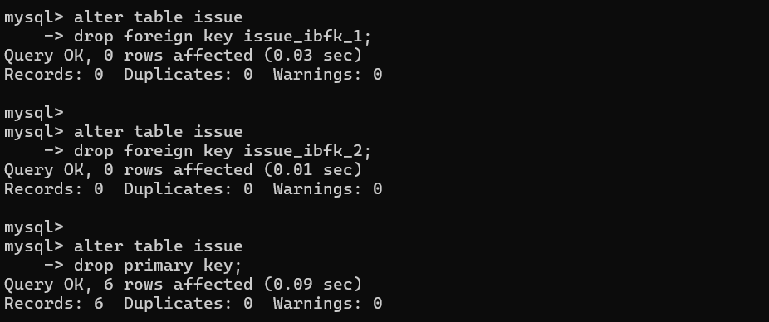25) Remove the constraints on Issue table

26) Insert a record in Issue table. The member_id should not exist in member table.

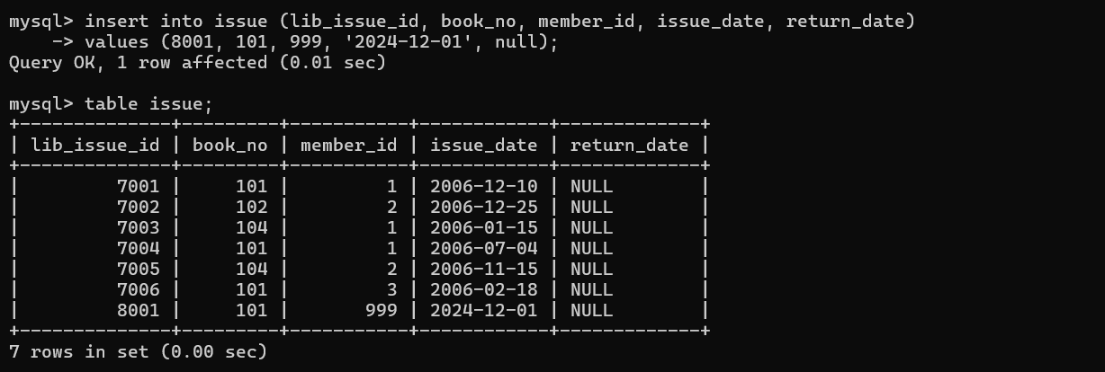

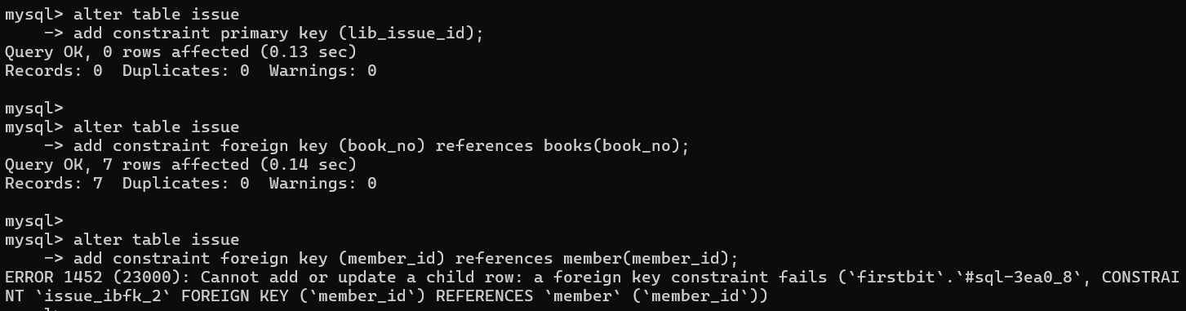27) Now enable the constraints of Issue table. Observe the error

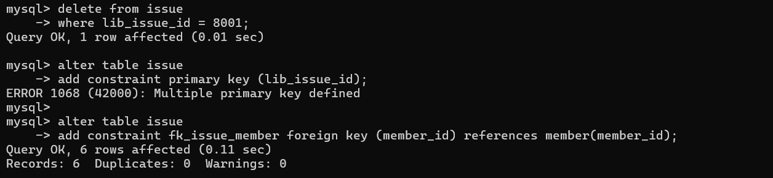28) Delete the record inserted at Q-27) and enable the constraints.

29) Try to delete the record of member id 1 from member table and observe the error .

30) View the data and structure of all the three tables Member, Issue, Book.

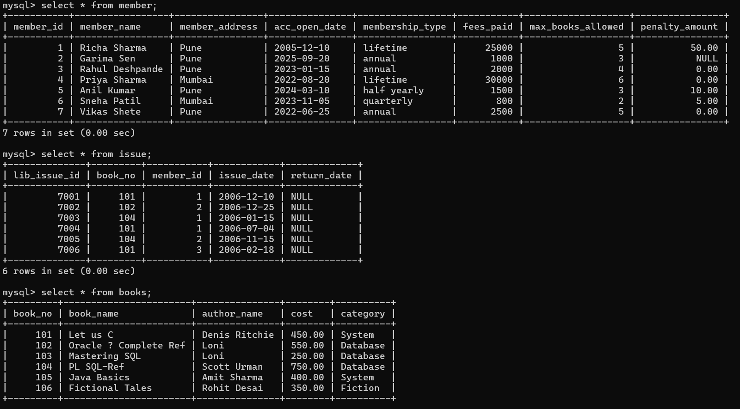

31) Modify the Return_Date of 7004,7005 to 15 days after the Issue_date.

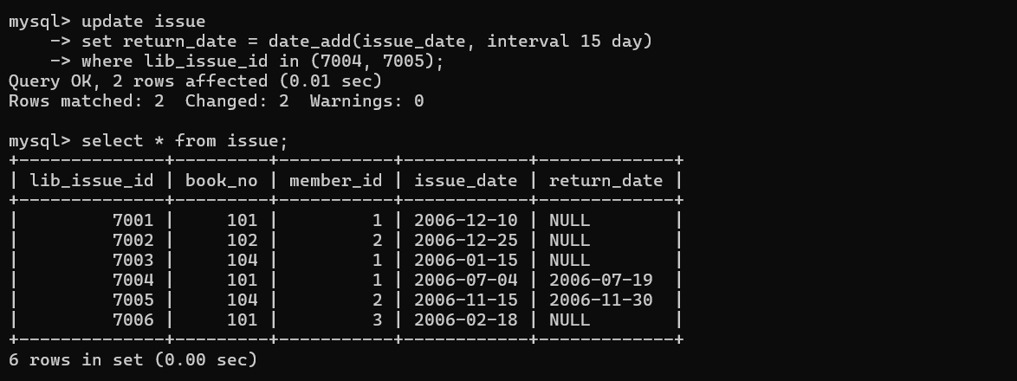

32) Remove all the records from Issue table where member_ID is 1 and Issue date in before 10-Dec-06.

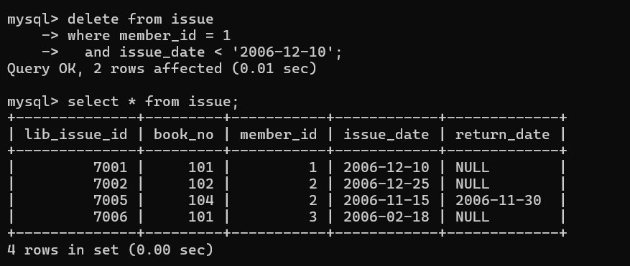

33) Remove all the records from Book table with category other than RDBMS and Database.



34) Remove the table Member.



35) Remove the table Book.

